MUSIC P1

FEBRUARY/MARCH 2018

MARKING GUIDELINES

NATIONAL

SENIOR CERTIFICATE

GRADE 12

GRAAD 12

MARKS: 120

These marking guidelines consist of 28 pages.

INSTRUCTIONS AND INFORMATION

1.  2.  3. | This question paper consists of FIVE sections, namely SECTIONS A, B, C,  D and E.  SECTIONS A and B are compulsory.  SECTION C: WESTERN ART MUSIC (WAM), SECTION D: JAZZ and SECTION E: INDIGENOUS AFRICAN MUSIC (IAM) are choice questions. Answer only ONE of these sections (SECTION C or D or E).

4.  5.  6. | Write all music notation in SECTION A in pencil and all written text in blue or black ink on this question paper.  Answer SECTION B and SECTION C or D or E in blue or black ink in the ANSWER BOOK provided.  Number the answers correctly according to the numbering system used in this question paper.

7.  8.  9.  10. | The last page of this question paper is manuscript paper intended for rough work. Candidates may remove this page.  Candidates may NOT have access to any musical instrument for the duration of this examination.  Candidates must take note of the mark allocation of each question in order to provide enough information in their answer.  Write neatly and legibly.

MARKING GRID

SECTION | QUESTION | MARKS | MARKER | MODERATOR
A: THEORY OF MUSIC  (COMPULSORY) | 1 | 20
 | 2 | 15
 | 3 | 10
 | 4 | 15
SUBTOTAL |  | 60
AND
B: GENERAL  (COMPULSORY) | 5 | 20
SUBTOTAL |  | 20
AND
C: WAM | 6 | 10
 | 7 | 5
 | 8 | 5
 | 9 | 5
 | 10 | 15
SUBTOTAL |  | 40
OR
D: JAZZ | 11 | 10
 | 12 | 5
 | 13 | 5
 | 14 | 5
 | 15 | 15
SUBTOTAL |  | 40
OR
E: IAM | 16 | 10
 | 17 | 5
 | 18 | 5
 | 19 | 5
 | 20 | 15
SUBTOTAL |  | 40
GRAND TOTAL |  | 120

SECTION A: THEORY OF MUSIC (COMPULSORY) (90 minutes)

Answer QUESTION 1
AND QUESTION 2.1 OR 2.2
AND QUESTION 3.1 OR 3.2
AND QUESTION 4.1 OR 4.2.

Answer the questions in the spaces provided on this question paper.

QUESTION 1 (25 minutes)

Study the extract from Send in the Clowns by Stephen Sondheim below and answer the questions that follow.

Adagio

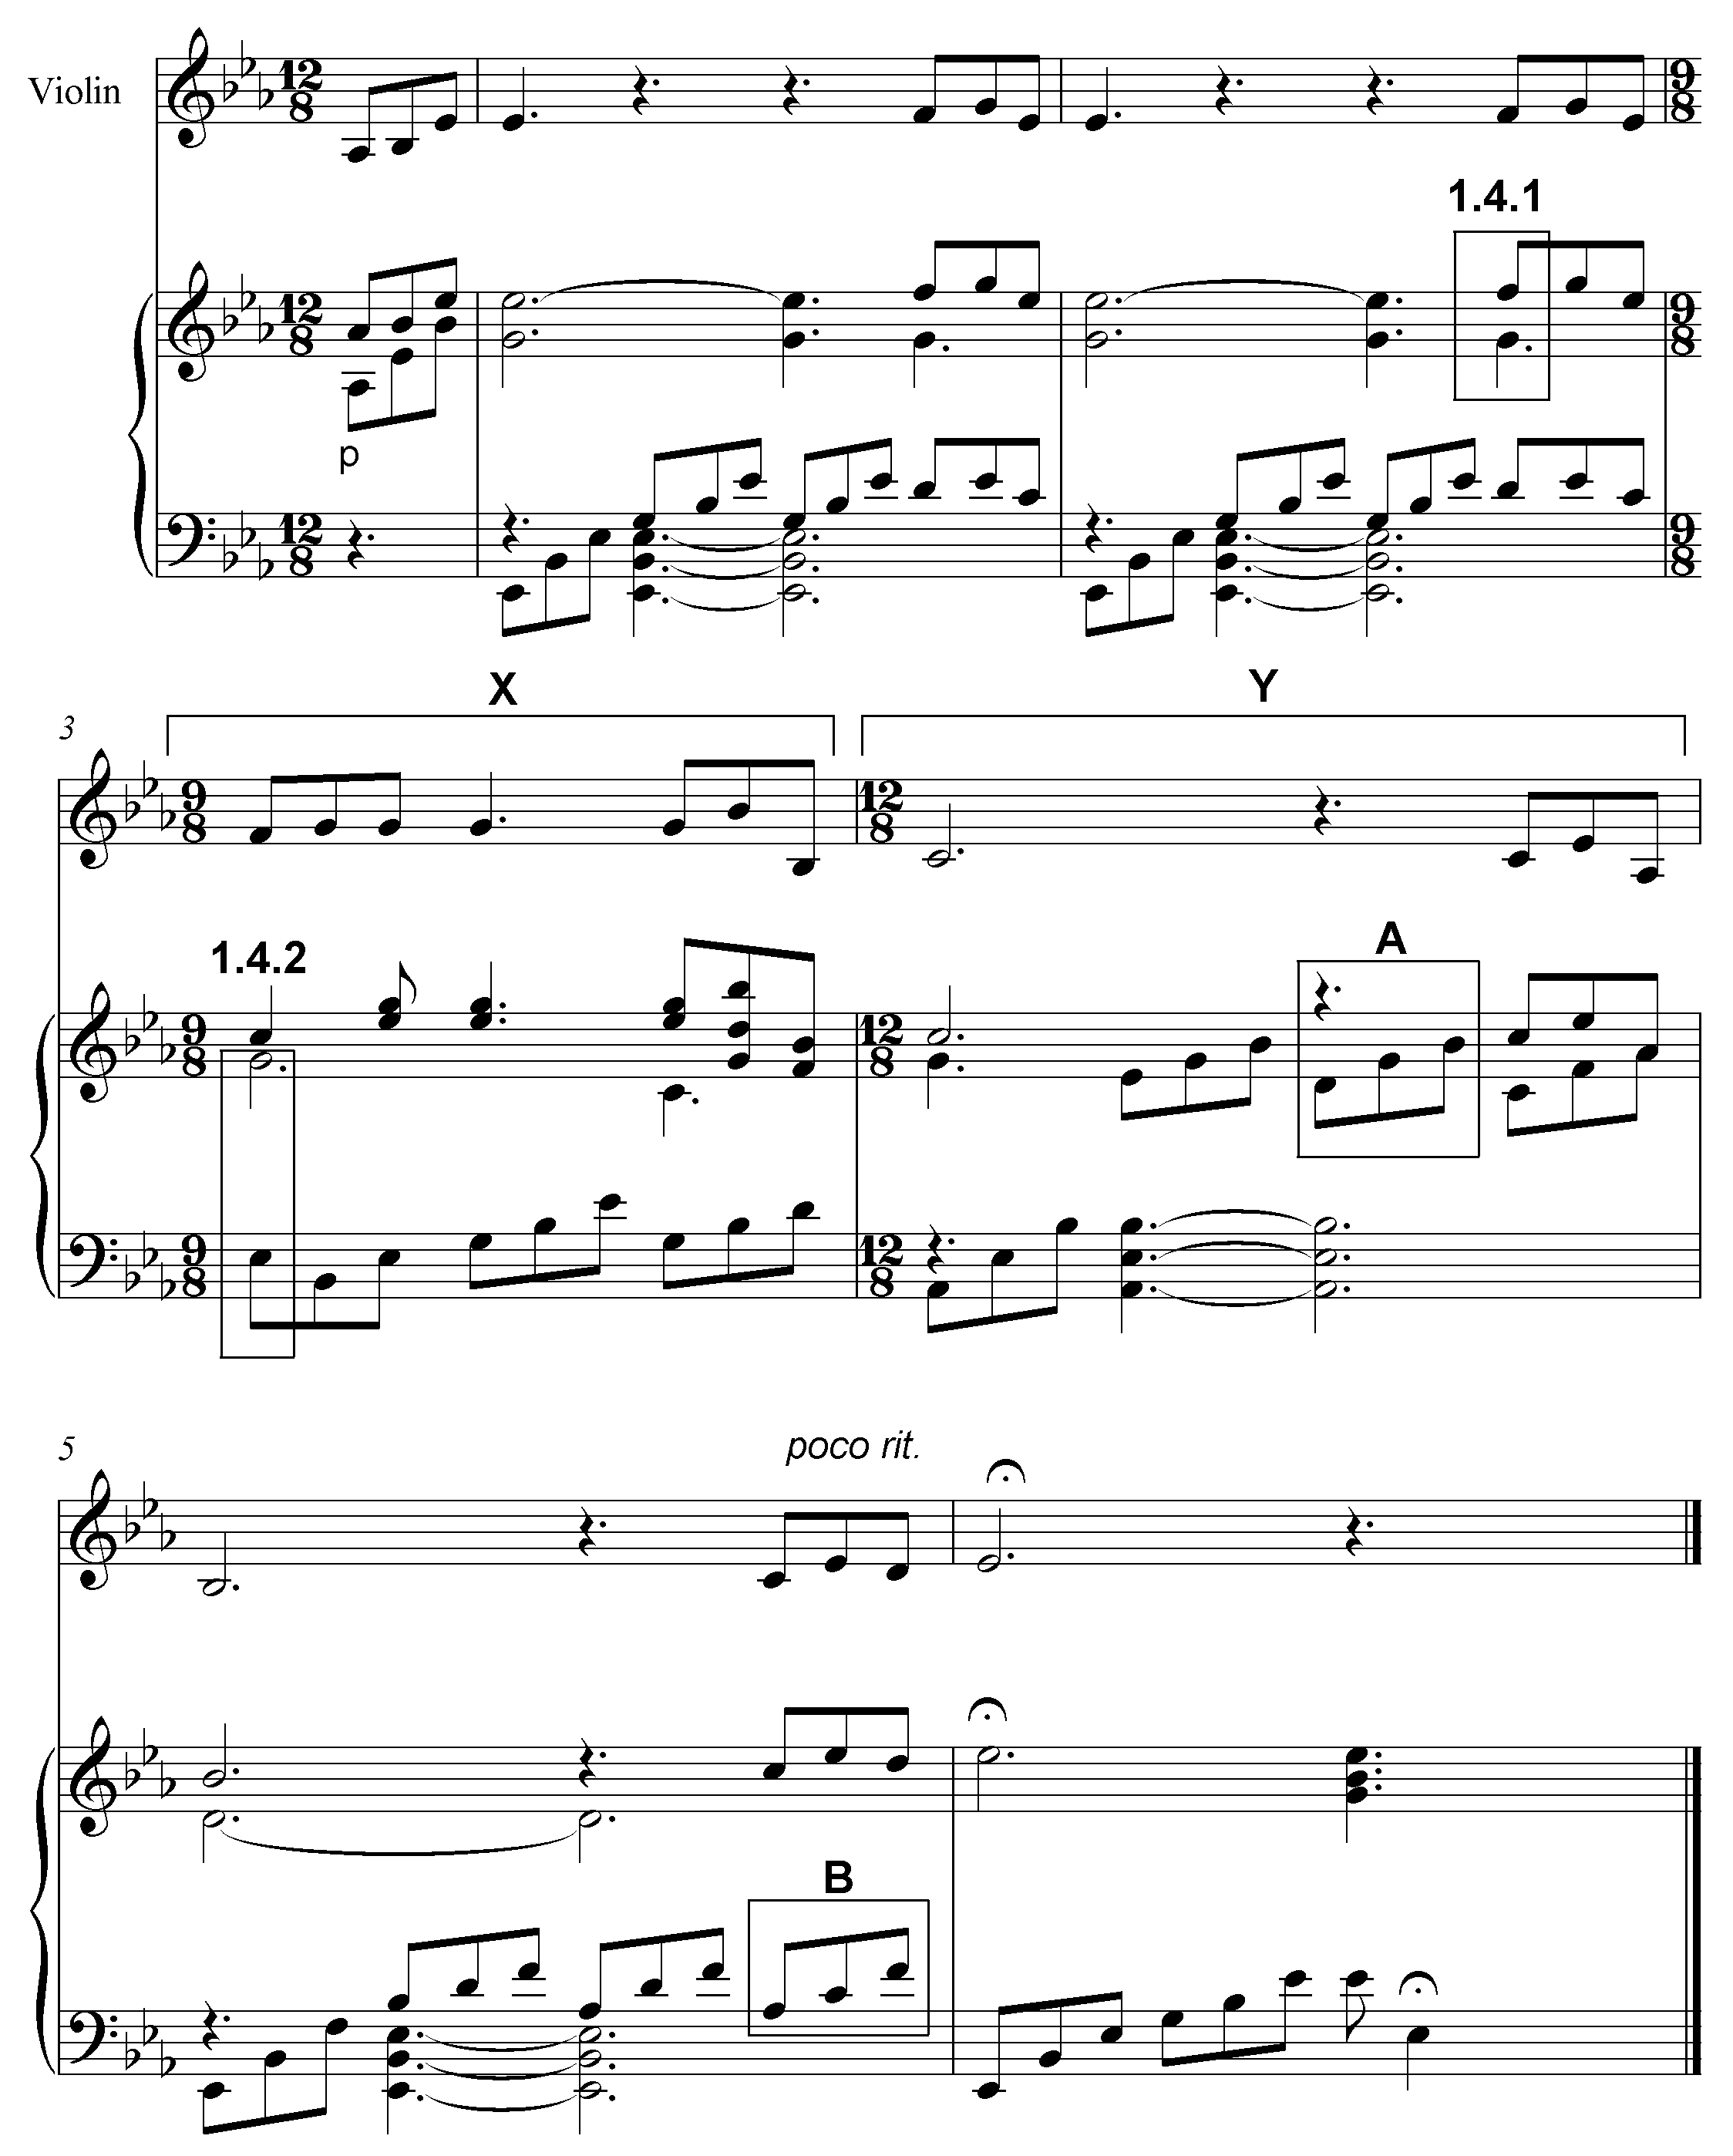

1.1 | Name the key of the work.
 | Answer:  E^{b} major = 1 mark |  | (1)

1.2 | What is the relative minor of the main key?
 | Answer:  C minor = 1 mark |  | (1)

1.3 | Transpose the first four notes of the violin part a major third higher on the given stave below. Use a new key signature.
 | Answer  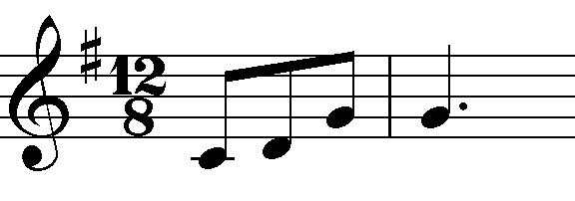  Key signature Notation (Minus ½ mark per mistake to a maximum of 1 mark) (No penalisation if time signature is left out) = 1 mark = 1 mark |  | (2)

1.4 | Name the intervals at 1.4.1 and 1.4.2 according to type and distance.
 | Answer:  1.4.1 Minor 7th  1.4.2 Major 10th/Compound Major 3rd  1 mark each  1.4.2 Major 3rd only = ½ mark  No mark for distance only |  | (2)

1.5 | Name the triads at A and B according to type and position, for example Major, second inversion. (Consider only the notes in the block.)
 | Answer:  A: Minor second inversion  B: Minor first inversion  Type Position = ½ mark each = ½ mark each (4 x ½) = 2 |  | (2)

1.6 | Rewrite the violin part at X using half the note values. Insert the new time signature.
 | Answer:  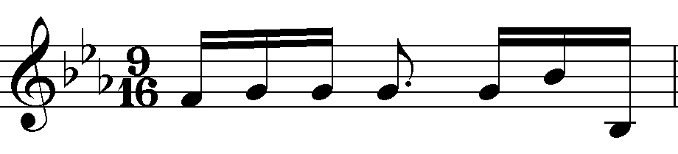  Time signature Notation (Minus ½ mark per error up to 1 mark) = 1 mark = 1 mark |  | (2)

1.7 | Rewrite the violin part at Y in the corresponding simple quadruple time, using the alto clef.
 | Answer:  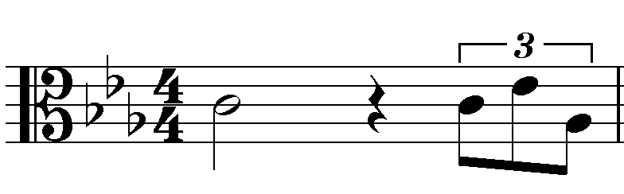  Clef Time signature Notation (Minus ½ mark per error up to 1 mark) = 1 mark = 1 mark = 1 mark |  | (3)

1.8 | Give the meaning of the Italian term, Adagio.  Answer:  Slow (tempo) = 1 mark |  | (1)

1.9 | In which scale/mode is the following melody written?  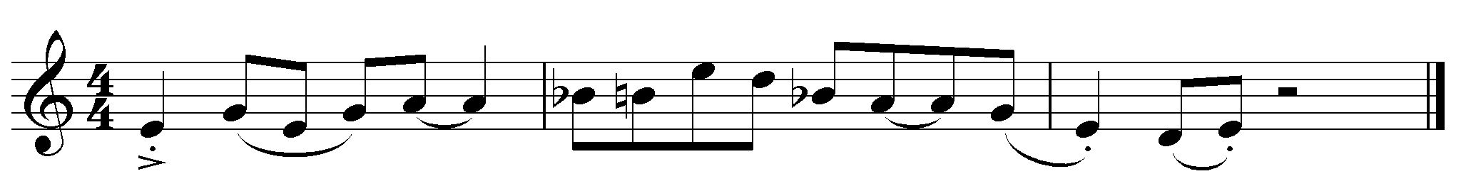
 | Answer:  Blues scale (on E) = 1 mark |  | (1)

1.10 | Write the melodic form of the B minor scale, descending, using the alto clef. Write without a key signature, use semibreves and mark the semitones.
 | Answer:  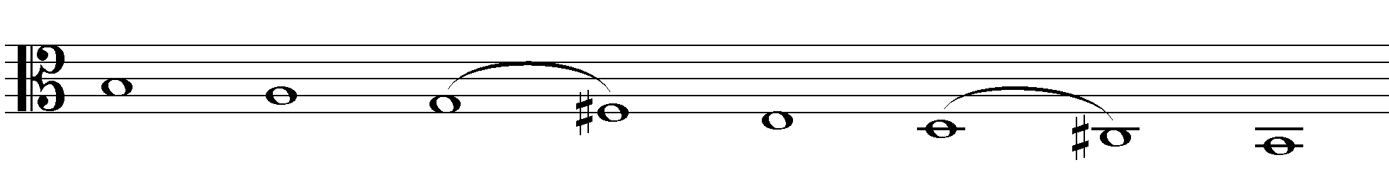  Clef = 1 mark  Semitones = ½ mark each = 1 mark  Notation = 1 mark  (Minus ½ mark per error up to a maximum of 1 mark) |  | (3)

1.11 | Complete the fragment by writing sequences of motif (a) in bars 2 and 3.  (a)  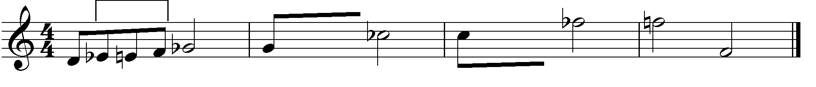
 | Answer:  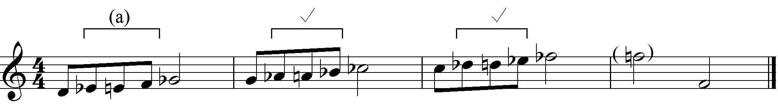  Alternative answer:  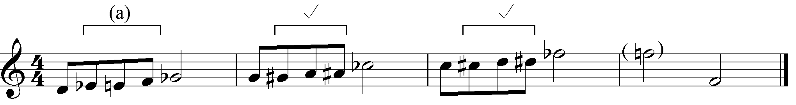  1 mark per sequence = 2 marks  (Minus ½ mark per mistake up to a maximum of 2 marks)  Any correct chromatic spelling must be accepted |  |  |  | (2)
 |  |  |  | [20]

QUESTION 2 (25 minutes)

Answer EITHER QUESTION 2.1 OR QUESTION 2.2.

2.1 | Complete the opening motif below to form a twelve-bar melody in ternary form for any single-line melodic instrument of your choice. Name the instrument for which you are writing. Indicate the tempo and add dynamic and articulation marks.

Concept answer:
Instruments: Bassoon, Trombone, Cello, Bass guitar, Double bass
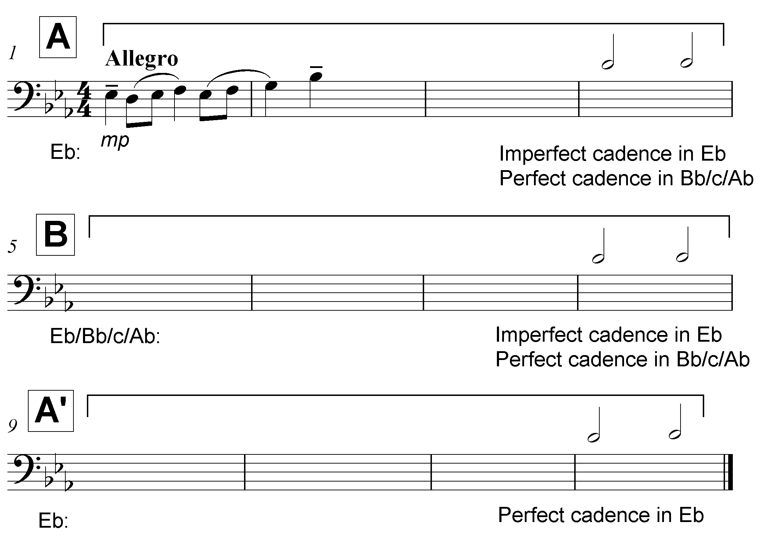
OR
2.2 | Concept answer:  Instrument: Flute, Oboe, Clarinet, Trumpet, Violin, Guitar, Saxophone, Marimba
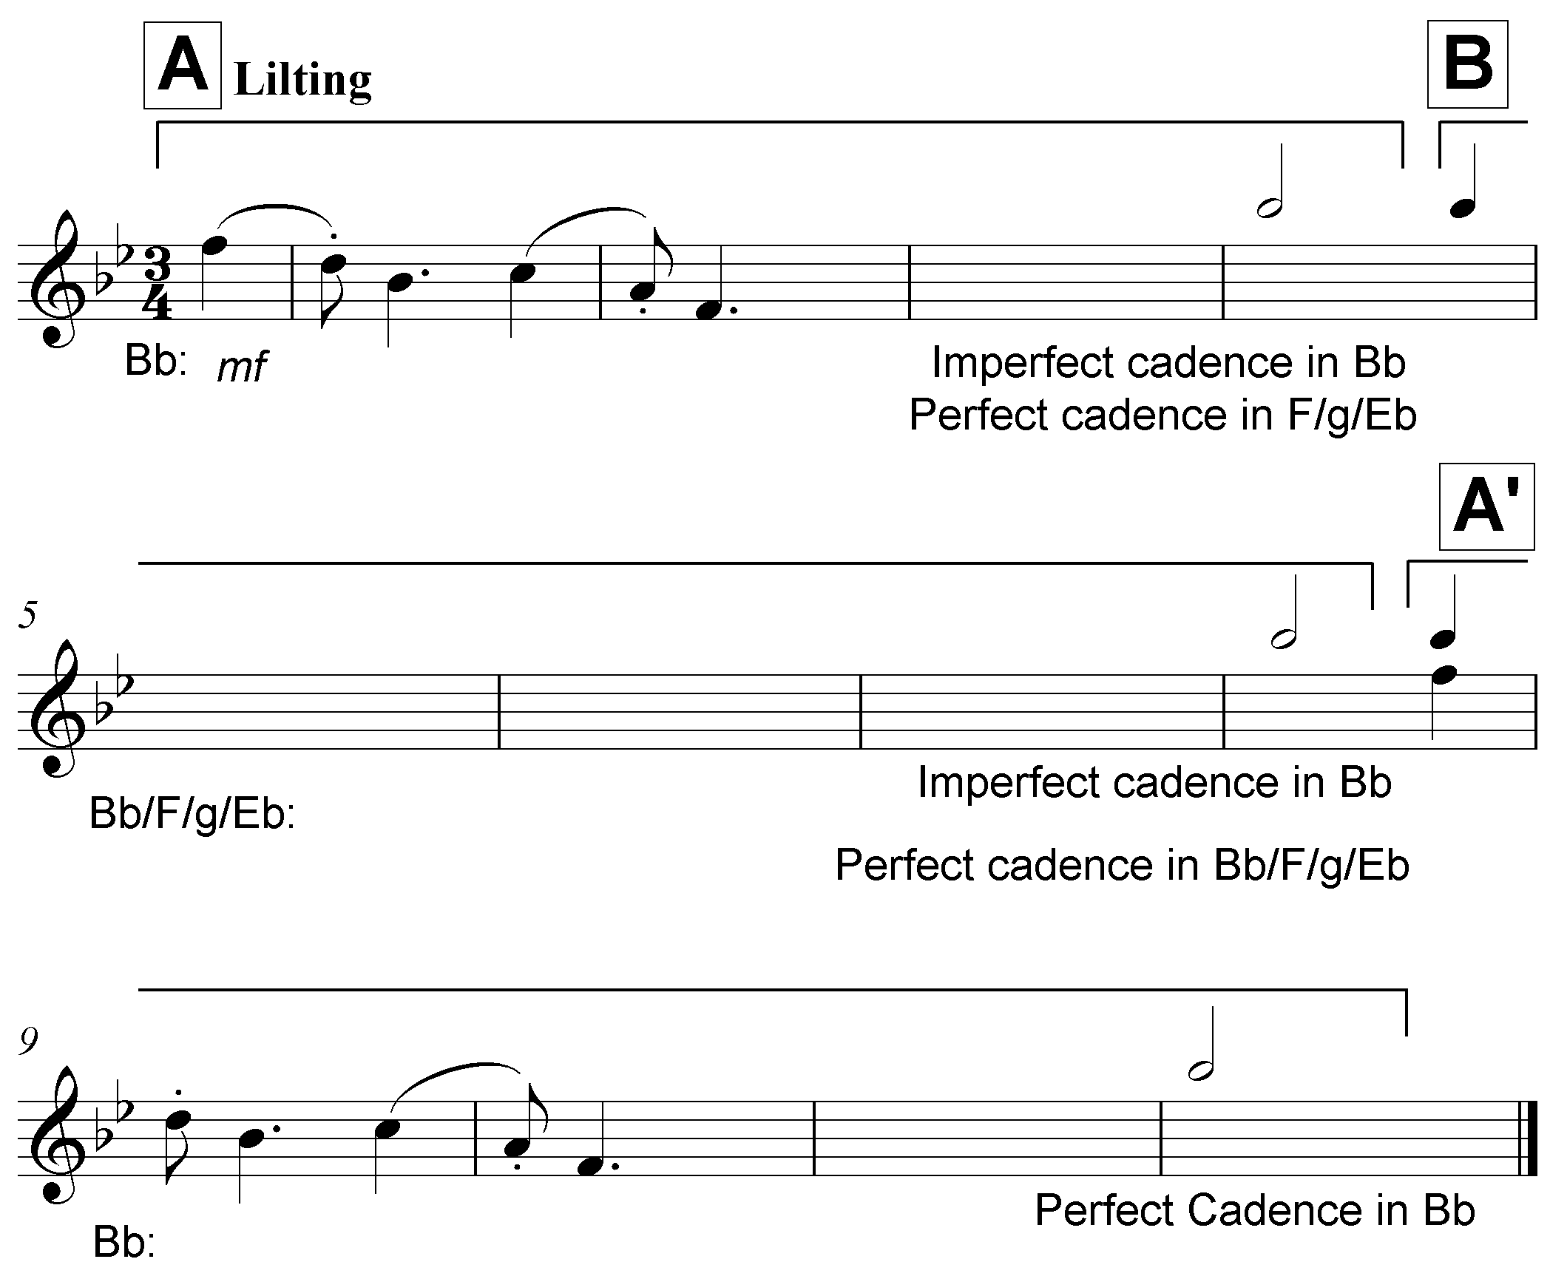

The melody will be marked according to the following criteria:

DESCRIPTION | MARK ALLOCATION
Form and cadential points | 1 mark per phrase x 3 |  | 3
Correctness  Note stems, beats per bar, accidentals, spacing | Minus ½ mark per error up to 2 marks |  | 2
Quality  - Quality of melody and  suitability for chosen  instrument  - Appropriateness of  tempo, articulation and dynamic indications  - Musicality | 9–10 | Excellent  Coherent and musical; phrases imaginatively define the form; opening motif innovatively continued; successful use of tonality; melodic shape masterfully handled; creative approach to choice of pitches and rhythm | 10
 | 7–8 | Good  Correct and musical; phrases clearly indicate the form; opening motif sensibly continued; stable tonality; melodic shape satisfying; choice of pitches and rhythm accurate
 | 4–6 | Average  Musically not convincing; not all phrases clear; opening motif not well utilised; tonality unstable; melodic shape is suspect; choice of pitches and rhythm unimaginative
 | 0–3 | Not acceptable  No musical sense; no sense of phrasing; opening motif ignored; no sense of tonal centre; no melodic shape; pitches and rhythm random
TOTAL | Markers may use ½ marks |  | 15

[15]

QUESTION 3 (10 minutes)

Answer EITHER QUESTION 3.1 OR QUESTION 3.2.

3.1 | Study the extract below and answer the questions that follow.

Answer:
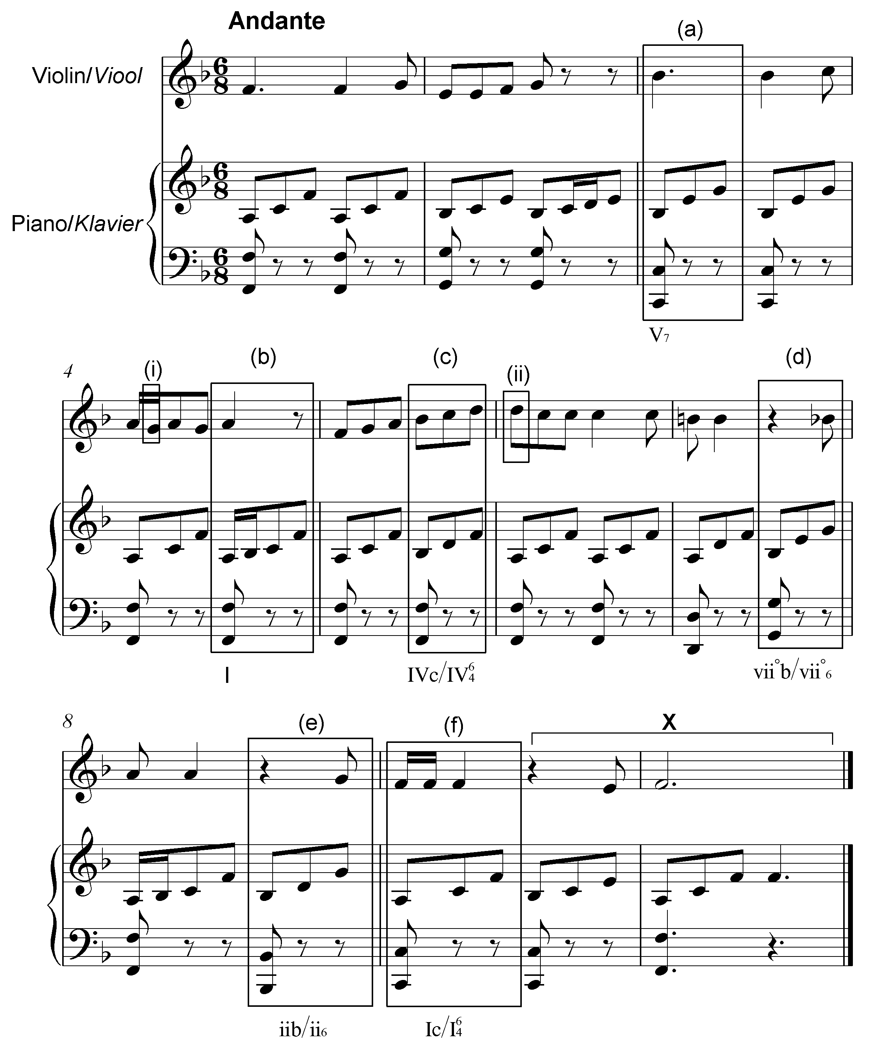

3.1.1 | Identify the chords from (a)–(f) and figure them on the score, e.g. iiib/iii₆
 | 1 mark per chord = 6 marks  (Minus ½ mark for each error)  (Key indication not compulsory)  V only = ½ mark  Answer:  See score: |  | (6)

3.1.2 | Name the type of non-chordal notes at (i) and (ii)
 | Answer:  (i) (Lower) Auxiliary note (ii) Suspension = 1 mark = 1 mark |  | (2)

3.1.3 | Identify the cadence at X. Write down the chord progression and the name of the cadence.
 | Answer:  V7 – I  Perfect (Cadence)  V7 – I V only = ½ mark Perfect (Cadence) = 1 mark = 1 mark |  | (2)

[10]

OR

3.2 | Study the extract below and answer the questions that follow.

Answer:
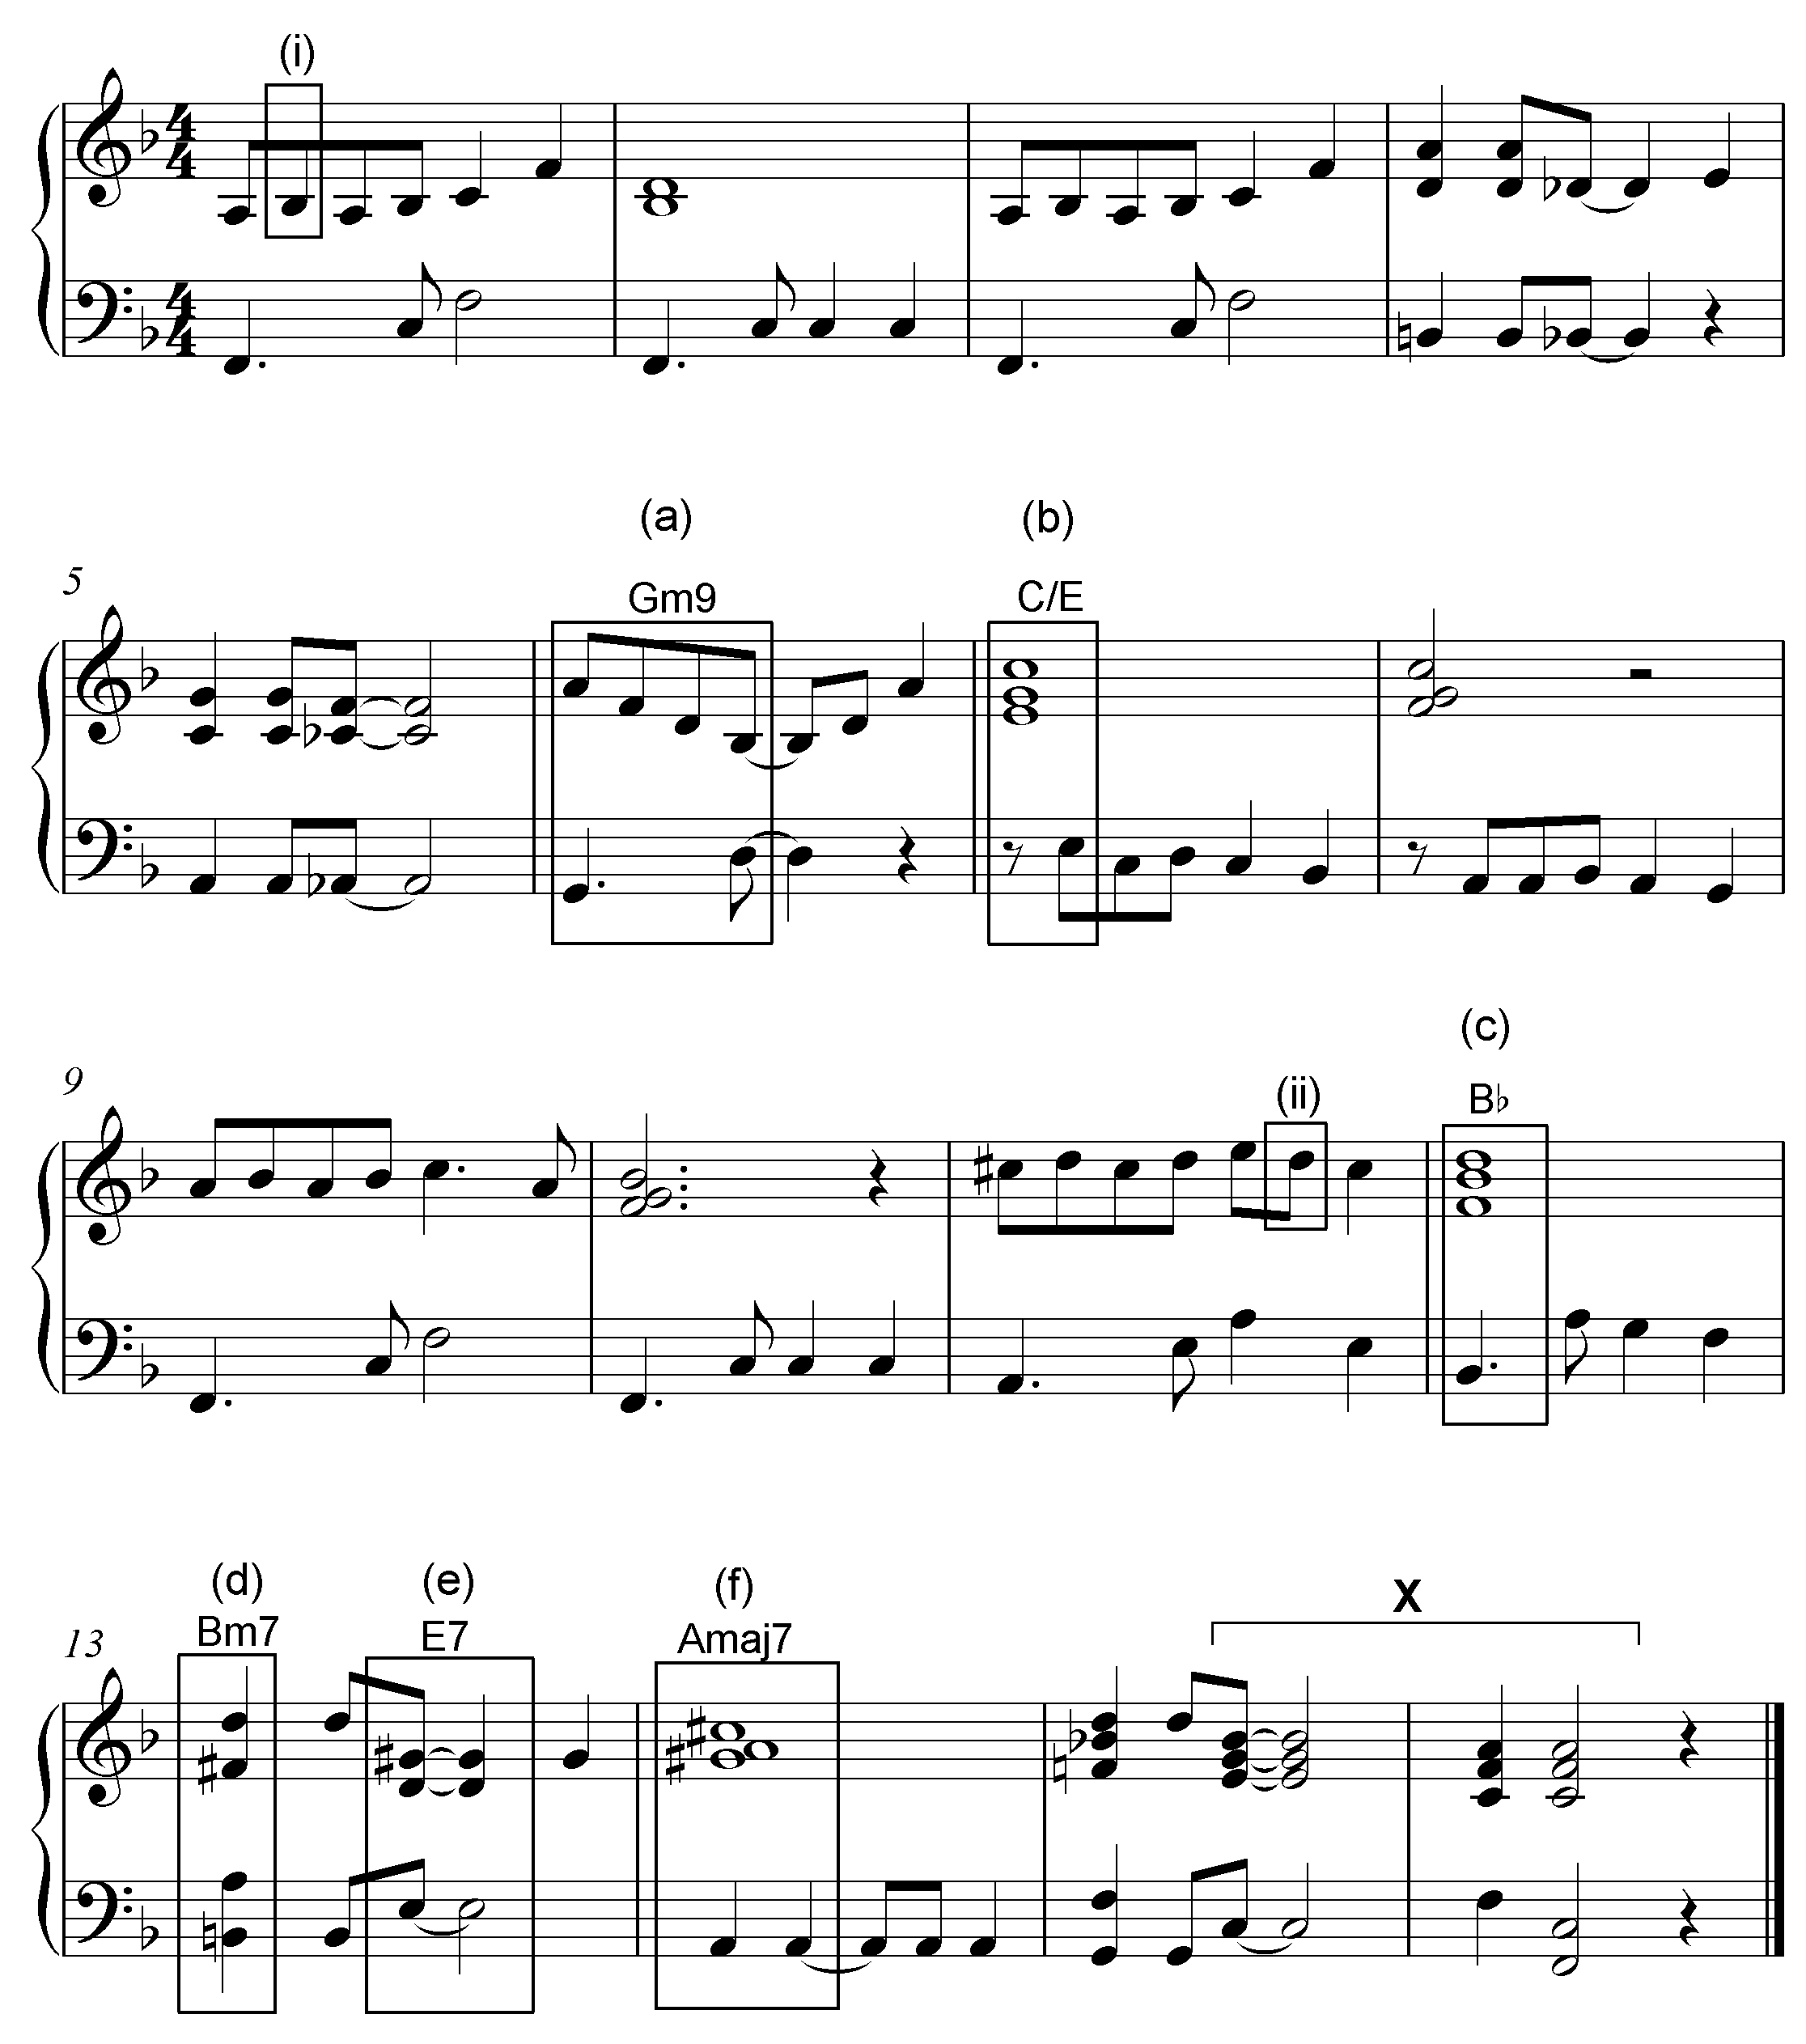

3.2.1 | Identify the chords from (a)–(f) and figure them on the score, e.g. B/F#
 | 1 mark per chord = 6 marks  (Key indication not compulsory)  If chord symbols are partially correct (e.g. 7th is missing) = ½ mark |  | (6)

3.2.2 | Name the type of non-chordal notes at (i) and (ii)
 | Answer:  (i) (Upper) Auxiliary note (ii) Passing note = 1 mark = 1 mark |  | (2)

3.2.3 | Identify the cadence at X. Write down the chord symbols and the name of the cadence.

 | Answer:  C7 (½ mark) – F (½mark) Perfect (Cadence) = 1 mark = 1 mark |  | (2)
 |  |  | [10]

QUESTION 4 (30 minutes)

Answer EITHER QUESTION 4.1 OR QUESTION 4.2.

4.1 | Complete the four-part vocal harmonisation below by adding the alto, tenor and bass parts.

Concept answer:

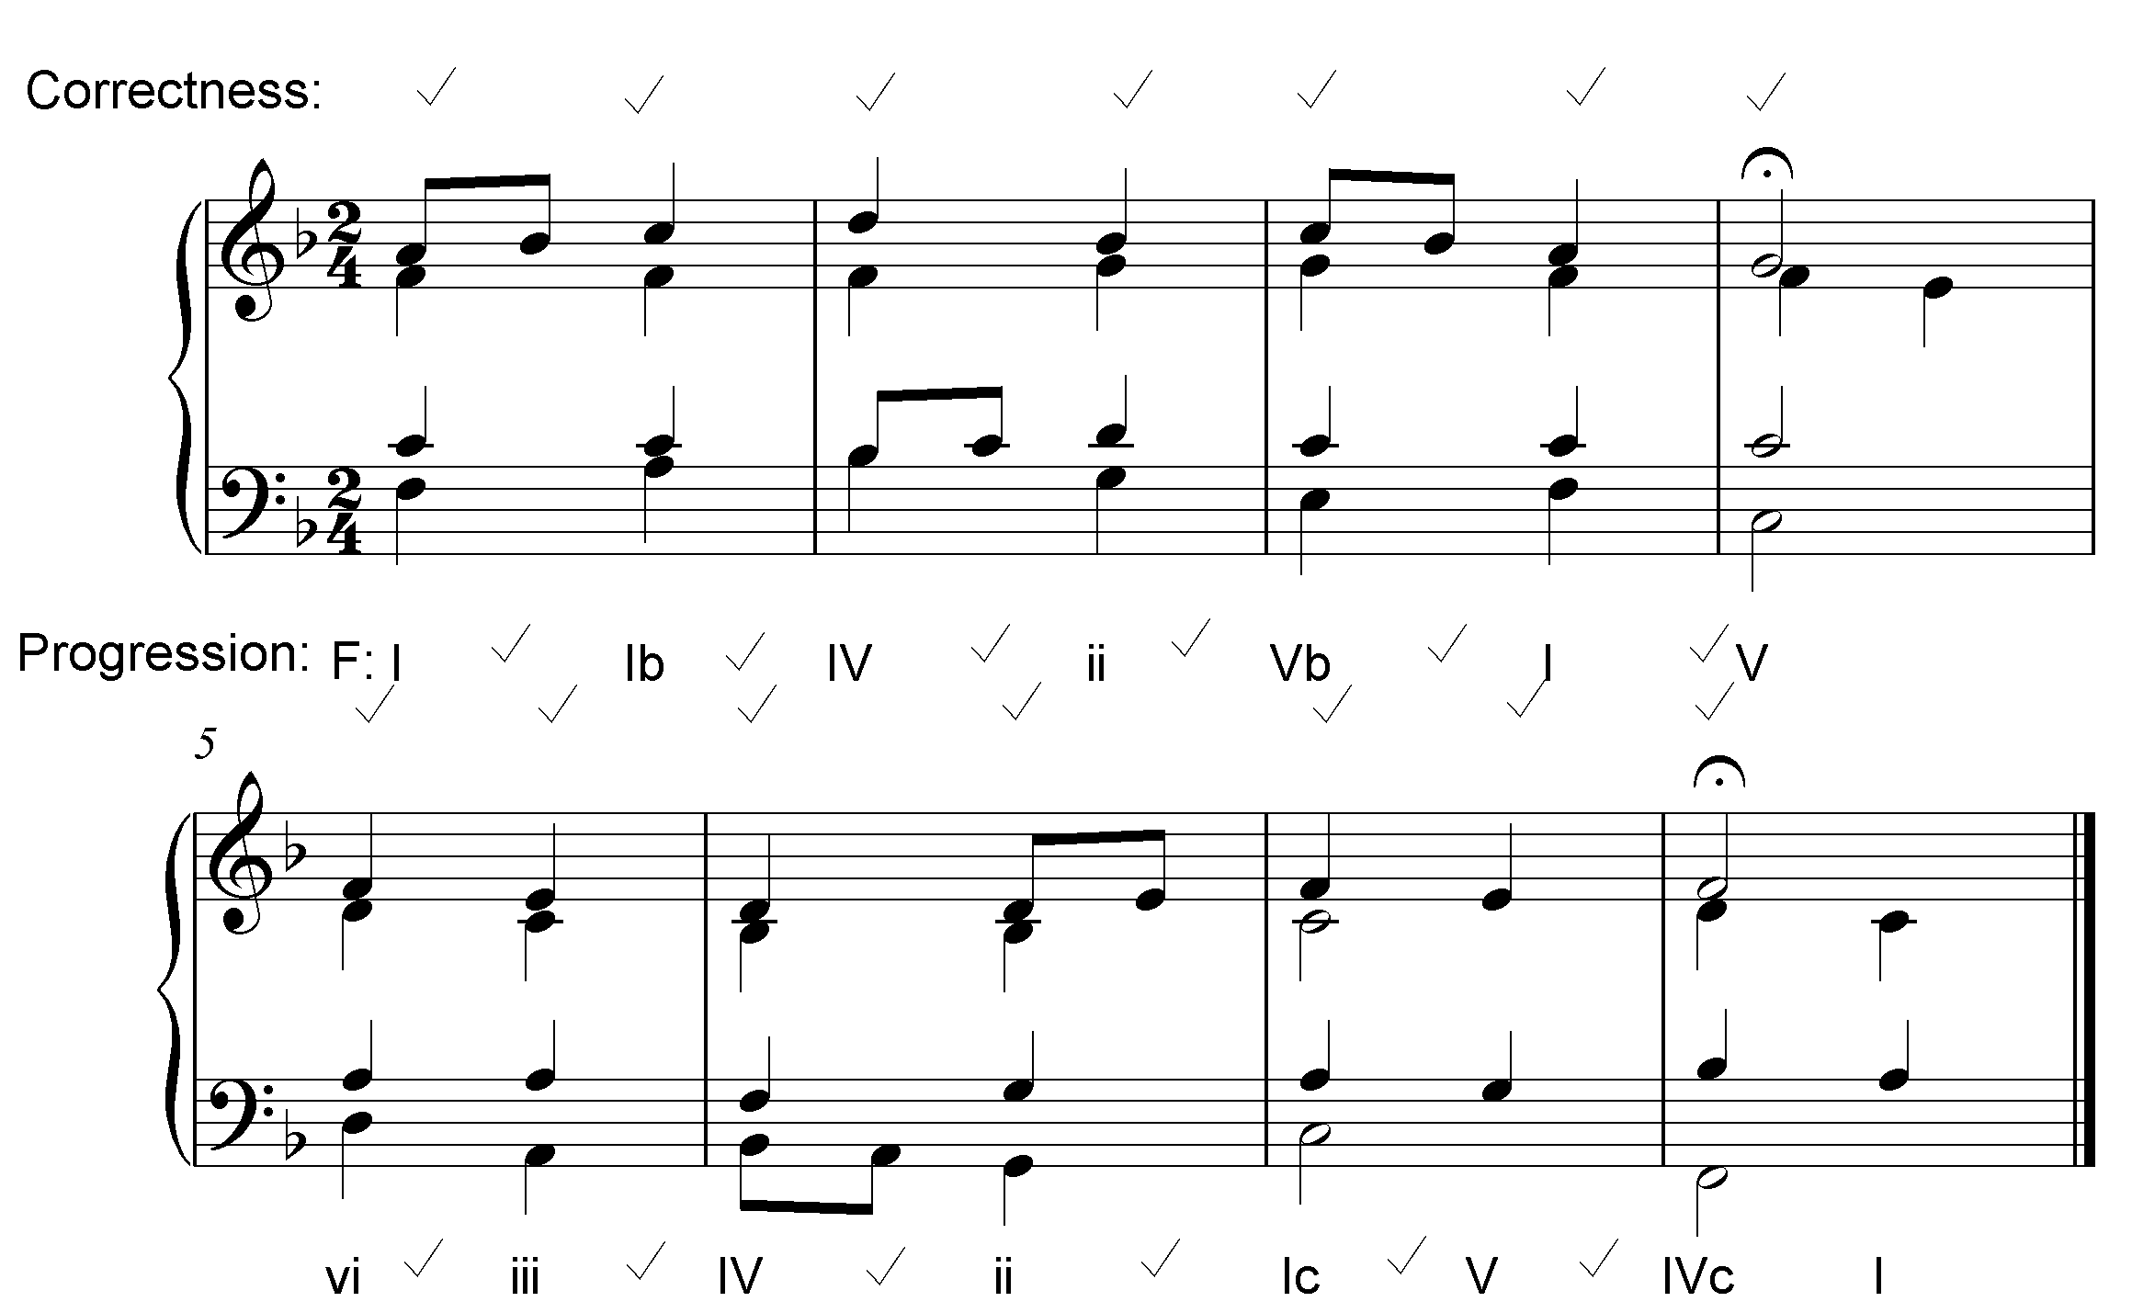

The answer will be marked according to the following criteria:
DESCRIPTION | MARK ALLOCATION
Chord progression  Choice of chords, correct use of cadence | 1 mark between each pair of chords  (except between bars 4 and 5) |  | 12
Correctness  Notation, doubling, spacing, voice leading | Minus ½ mark per error but not more than 1 mark per chord |  | 14
Quality  Musicality, non-chordal notes, awareness of style, creativity | • Excellent  • Good  • Average  • Weak  • Unacceptable | = 3½–4 marks  = 2–3 marks  = 1½–2½ marks  = 1 mark  = 0 marks | 4
 | Note to marker:  Mark out of 30 must not contain a ½ mark |  | 30÷2 = 15
TOTAL |  |  | 15

[15]

OR

4.2 | Complete the piece below by adding suitable harmonic material in the open stave. Continue in the style suggested by the given material in bar 1.

Concept answer:
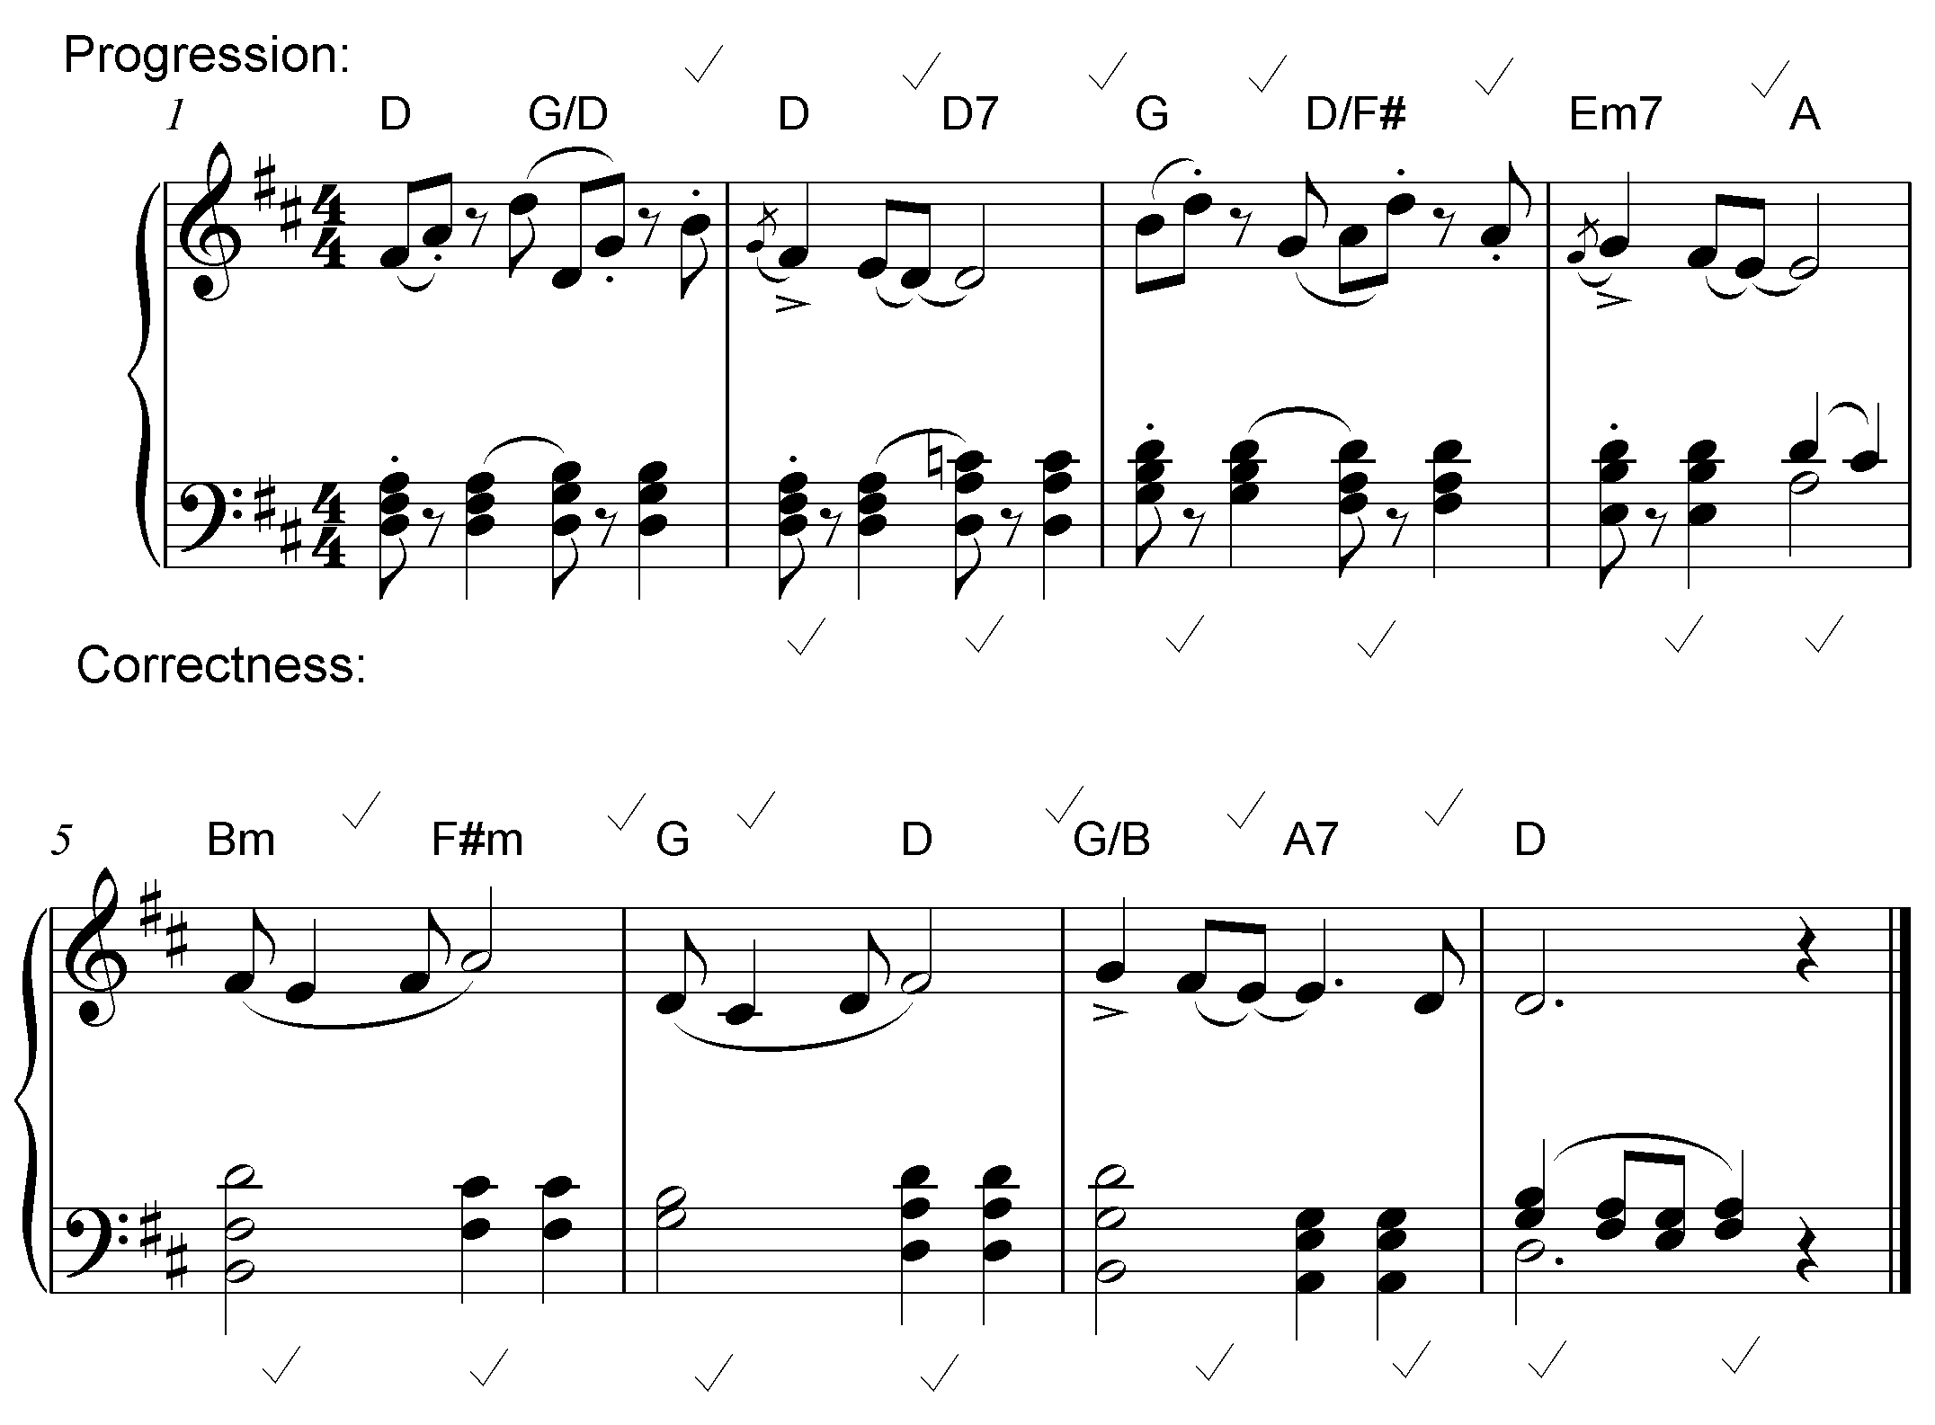

The answer will be marked according to the following criteria:
DESCRIPTION | MARK ALLOCATION
Chord progression  Choice of chords, correct use of cadence | 1 mark between each pair of chords  (except between bars 4 and 5) |  | 12
Correctness  Notation, spacing, voice leading | Minus ½ mark per error but not more than 2 marks per bar |  | 14
Quality  Musicality, non-chordal notes, awareness of style, creativity | • Excellent  • Good  • Average  • Weak  • Unacceptable | = 3½–4 marks  = 2–3 marks  = 1½–2½ marks  = 1 mark  = 0 marks | 4
 | Note to marker:  Mark out of 30 must not contain a ½ mark |  | 30÷2 = 15
TOTAL |  |  | 15

[15]

TOTAL SECTION A: |  | 60

SECTIONS B, C, D, E: GENERAL MUSIC KNOWLEDGE (90 minutes)

Answer SECTION B
AND SECTION C (Western Art Music)
OR SECTION D (Jazz)
OR SECTION E (Indigenous African Music).

Answer these questions in the ANSWER BOOK provided.

SECTION B: GENERAL (COMPULSORY)

QUESTION 5

5.1 | 5.1.1 | C
 | 5.1.2 | B
 | 5.1.3 | D
 | 5.1.4 | D
 | 5.1.5 | C
 | 5.1.6 | D
 | 5.1.7 | C
 | 5.1.8 | A
 | 5.1.9 | D
 | 5.1.10 | C |  | (10)

5.2 | A B  5.2.1 Idiophone M  5.2.2 Ostinato C  5.2.3 Chordophone A  5.2.4 D.C. N  5.2.5 Call and response L  5.2.6 A cappella K  5.2.7 Improvisation H  5.2.8 Ternary form D  5.2.9 Very fast Q  5.2.10 Falsetto B |  | (10)
 | TEN correct answers = 10 marks |  | [10]
TOTAL SECTION B: |  | 20

Answer SECTION C (WAM)
OR SECTION D (JAZZ)
OR SECTION E (IAM).

SECTION C: WESTERN ART MUSIC (WAM)

QUESTION 6

6.1 | 6.1.1 | - Three large subdivisions: Minuet (A), Trio (B), Minuet (A); Each section (A – aaba; B – ccdc; A aaba); usually in rounded binary form (compound ternary form)  - The Trio (B) is usually different in character and key from Minuet  - A – Tonic, B – Tonic or Related key; A – Tonic
 |  | TWO correct facts relating to form = 2 marks  One correct fact relating to key = 1 mark |  | (3)

6.1.2 | - ABACA (or ABACADA Old Rondeau)  - The main section or theme, A, returns after each contrasting  (B/C) section (episodes)  - A – Tonic, B – Related key (dominant), A – Tonic, C – Related key (relative minor), A - Tonic
 | TWO correct facts relating to form = 2 marks  One correct fact relating to key = 1 mark |  | (3)

 | (3 x 2) |  | (6)

6.2 | - Dramatic work for voices and orchestral accompaniment  - Combines music, drama, costumes, décor and often dance |  | (2)

1 mark for 'voices and orchestra'
1 mark for idea of 'combination'

6.3 | Opera buffa  - Opera with comic subject matter  - Stories often light-hearted and romantic  - The comic characters are from the working class e.g. maids, peasants, servants  Opera seria  - Opera with serious subject matter  - Stories often tragic or heroic  - Typically involves royalty or ancient myths and gods

 | Correct fact for Opera Buffa = 1 mark  Correct fact for Opera Seria = 1 mark |  | (2)
[10]

QUESTION 7

Form
- Sonata form
- Exposition, Development, Recapitulation, Coda
- Uses a new genre: concert overture
Keys
- Begins in B minor
- Second subject in D major (modulates to relative major)
Harmony
- Uses classical, tonal harmony
Dynamics
- Wide dynamic range: pp to ff
- Expressive use of dynamics to depict nature through sound
Mood
- Brooding mood initially depicting the seascape
- Mood changes according to the suggested program
ONE correct answer from each element | = 5 marks

[5]

QUESTION 8

Aria: Definition
- An aria written for solo vocalist with instrumental accompaniment
- A song used for stating a particular emotion(s) of a character
TWO correct facts = 2 marks

Mood: Der Hölle Rache
- Depicts a fit of vengeful rage and anger - minor key, fast tempo, ff-dynamics
- Dark impressive mood and dramatic drive – fast tempo, extreme melodic range
- Dramatic flair, theatrical emphasis and spectacle of voice – short melodic phrases, coloratura soprano
THREE correct facts = 3 marks |  | [5]

QUESTION 9

9.1 | A: Hebrides or Fingal's Cave  B: Pastorale Symphony no 6, 1st movement  C: Overture to The Magic Flute

 | Correct answers = 3 marks  (Answers must be complete – no ½ marks) |  | (3)

9.2 | A: Violas/cellos  B: Violins

 | Correct answers = 2 marks |  | (2)
[5]

QUESTION 10

Programmatic content:
- Given a title: The Pastoral Symphony
- Also published as A recollection of country life
- One of Beethoven's few works containing clear programmatic content
- Its extra-musical purpose is an expression of his love of nature
- All the movements are given a title:
- First movement: Awakening of cheerful feelings upon arriving in the country
- Second movement: Scene by the brook
- Third movement: Happy gathering of country folk
- Fourth movement: Storm
- Fifth movement: Shepherds' song; cheerful and thankful feelings after a storm
- The last three movements are performed as one without pause – to add to the realistic picture of a storm from the emergence, to its climax and then relief at the end

Any SIX correct facts = 6 marks

Instrumentation/Tone painting
- First movement: involves a typical pastoral picture (F major; 6/8)
e.g. the opening drone of an open fifth in the lower strings (typical of a 'pastorale)'
- Second movement: includes the famous birdcalls:
- Flute for the nightingale
- Oboe for the quail, and
- Two clarinets for the cuckoo
- Third movement: Typical boisterous, country dance music (Lȁndler)
by peasant folk
- Fourth movement: A realistic portrayal of thunder and rain
Uses instruments effectively to imitate storm
- Cellos and double basses and timpani - announce the storm
- Staccato sounds of the violins render the falling raindrops
- Timpani - the thunder
- Piccolo contributes the climax and terror of storm
- Arpeggiated figures in the strings – the lightning
- Additional trombones to emphasize the intensity of the storm
- Fifth movement: A remembrance/reflection and continuation of this idealised pastoral scene
- Uses instruments effectively to imitate a calmness of mood
- Returns to F Major (tonal stability) to re- establish the pastoral mood
- Establishes a true paradise, a pastoral scene in its simplicity
e.g. yodelling of the clarinet and horn in opening bars, lilting character (in 6/8 time signature)

Any SIX correct facts = 6 marks

The essay will be marked according to the following criteria:
CRITERIA MARK ALLOCATION  Programmatic content : 1 mark for each correct fact X 6 6  Instrumentation/Tone painting: 1 mark for each correct fact X 6 6  Logical presentation and structure of the essay Excellent An introduction, conclusion, with a substantial argument in the body of essay evident. = 3 marks 3  Good An introduction, conclusion, with a reasonable argument in the body of essay evident. = 2 marks  Average An introduction, conclusion, with an insignificant argument in the body of essay evident. = 1½ marks  Below average An introduction, conclusion with a weak argument in the body of essay evident. = 1 mark  Weak A single paragraph. A poor attempt at an essay. = ½ mark  Not acceptable Only facts in bullet form. = 0 marks  TOTAL 15 |  | [15]

TOTAL SECTION C: |  | 40
GRAND TOTAL: |  | 120

OR

SECTION D: JAZZ

QUESTION 11

11.1 | Melody  - Folk-like melodies - narrow range, largely stepwise  - Blues song character  - Improvisational  Rhythm  - Ghoema beat - 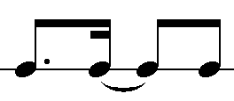 at a fast tempo (syncopated)  - Blends African (Xhosa) and Swing elements  Any TWO correct facts, one for each element = 2 marks |  | (2)

11.2 | - Solo pennywhistle playing  - Moderate to upbeat tempo  - Skiffle-like beat  - Jive/Swing rhythms - 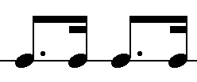 pattern repeated constantly  - Weaving of different melody lines together  - Melody developed through improvisation  Any FOUR correct facts = 4 marks |  | (4)

11.3 | 11.3.1 | Marabi
 | 11.3.2 | Mbaqanga
 | 11.3.3 | Cape Jazz
 | 11.3.4 | New Jazz/Jazz in Exile
 | Correct answers = 4 marks |  |  | (4)
 |  |  |  |  | [10]

QUESTION 12

Dolly Rathebe
- Contributed to African vocal jazz styles
- Contributed to the developing Afro-pop genre
- Popularised local African songs/compositions
- Contributed to South African protest music
- Incorporated the American swing idiom with lyrics in African languages
- Woza (1991) or A Call for Peace (1995) or Siya Gida – We dance (1997)

Any FIVE correct facts = 5 marks

Thandi Klaassen
- Forming of the first all-girl group, The Quad Sisters
- 50 years of performing
- Awarded: Woman of Distinction - for outstanding musical role in the political struggle
- Performed in international jazz Opera King Kong
- Blended blues, jazz and Xhosa music in her personal vocal style
- Sophiatown or any other correct song

Any FIVE correct facts = 5 marks

Miriam Makeba  - Sang modern versions of indigenous songs in her mother tongue isiXhosa  - Documentary: Amandla!: A Revolution in Four-Part Harmony about the struggles of black South Africans against the injustices of apartheid through the use of music  - Has historical significance as a result of her inspiring activism against Apartheid through music  - With the release of Phata Phata in 1967 in the USA, Makeba gained international recognition for South African music, highlighting awareness of the plight of the majority of South Africans  - Earned an international reputation not only as a musician but also as a cultural activist opposed to the segregationist policies of apartheid  - First female artist from South Africa to popularize African music around the world  - Recorded and toured with many popular artists such as Harry Belafonte and Paul Simon  - Received a Grammy Award for Best folk recording with Harry Belafonte  - Performed in the International Jazz Opera, King Kong  Any FIVE correct facts = 5 marks |  | [5]

QUESTION 13

- A mixture of hard-driving blues (Charles Mingus) and wild experimentalism (Sun Ra)  - Unique sound due to the South African influences – cyclic harmonic progression, consecutive parallel movement, repetitive rhythmic patterns  - Avant Garde (atonal) arrangements and experimental music  - Dynamic Big Band ensemble  - Sophisticated instrumental arrangements  - In the earlier stages musical freedom and development of individuality, prominent  - Later arrangements were more controlled resulting in less free improvisation  - A mixture of South African traditional music and the more progressive American contributions to jazz  Any FIVE correct facts = 5 marks |  | [5]

QUESTION 14

- A typical mbaqanga song begins with a brief improvised introduction
- Introduction features a rhythmically ambiguous line from a solo guitar
- Drums and bass guitar set a four-bar chord sequence from which the piece will grow
- Call and response is used in the vocal passages
- Call and response used between voices and instruments
- Bass lines play an important role in mbaqanga songs
- they provide the harmonic framework
- often repeat rhythmic and melodic ideas found, repeated and strengthened in the vocal lines
- Mbaqanga keeps the dance-like stylistic characteristics
- Has more powerful sound and harder driving beat than kwela and other dance genres
Any FIVE correct facts = 5 marks

[5]

QUESTION 15

Traditional influences
- A mixture of music styles from different South African cultures
- African traditional ceremonial songs
- Well-known African songs usually (umbholoho-wedding songs) arranged to suit dance performances
- African Christian hymns which would be jazzed up to suit the dance performances
- Two varieties of Marabi
- Xhosa: Thula ndivile - name derived from a popular marabi song of the same name
- Zulu: Ndunduma derived its name from the mine dumps in Johannesburg
- Sometimes lyrics contained social commentary or protest
- Afrikaans music: tiekiedraai, vastrap
- Ghoema music of the Cape Malay
- Nguni dance music: standard drum pattern with marked rhythmic emphasis:
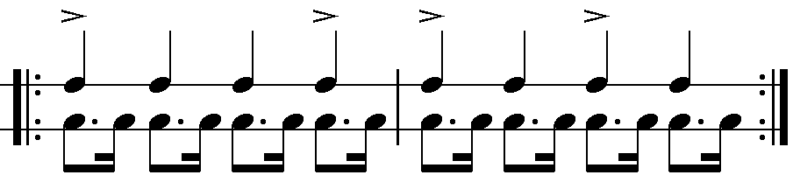
- Repetitive harmonic patterns: I – IV – Ic – V - I
- Improvised melodies are superimposed on the repetitive harmonic patterns

Any SIX correct answers = 6 marks

International influences
- Early American Jazz
- Popular dance tunes
- Mixed instrumental groups e.g. keyboard, guitar and banjo
- Pedal organ
- One chord (I – IV– I 6/4 –V) per beat
- Ragtime
- Ragtime-based rhythms
- Use of piano
- Moderate to fast tempo
- Blues
- Cyclic chord structure and harmonic pattern
- Use of guitar, banjo
- Cycle extends over four bars
- American spirituals
- Military Band music
- Western Church hymns
Any FOUR correct answers = 4 marks

Artist and song
- The Jazz Maniacs: Gully Low Blues
- The Manhattan Brothers: Jikela Emaweni
- Mahotella Queens: Marena

Any ONE artist with a corresponding song = 2 marks

The essay will be marked according to the following criteria:
CRITERIA MARK ALLOCATION  Traditional influences 1 mark for each correct fact X 6 6  International influences 1 mark for each correct fact X 4 4  Artist and song 1 mark for each correct fact X 2 2  Logical presentation and structure of the essay Excellent An introduction, conclusion, with a substantial argument in the body of essay evident. = 3 marks 3  Good An introduction, conclusion, with a reasonable argument in the body of essay evident. = 2 marks  Average An introduction, conclusion, with an insignificant argument in the body of essay evident. = 1½ marks  Below average An introduction, conclusion with a weak argument in the body of essay evident. = 1 mark  Weak A single paragraph. A poor attempt at an essay. = ½ mark  Not acceptable Only facts in bullet form. = 0 marks  TOTAL 15 |  | [15]
TOTAL SECTION D: |  | 40
GRAND TOTAL: |  | 120

OR

SECTION E: INDIGENOUS AFRICAN MUSIC (IAM)

QUESTION 16

16.1 | - Deep rural isiZulu musical tradition developed from imbongi (traditional Zulu poetry)  - Izihlabo (introduction) in free meter; time signature always in 4/4; tonality always major; concertina often used in the introduction; guitar predominantly used  TWO sentences = 2 marks |  | (2)
16.2 | - Lyrics are in different African languages  - Merges drum melo-rhythms with pluro-vocal responses, crepitations and vocal lilting  - Traditional drums e.g. Ditinti; Moropa wa diatla/Moropa; Kiba and other traditional African percussion used  - Traditional African dances (usually Sepedi) employed  - Polyrhythms between different instruments  - Call and response  - Direto (praise poetry)  Any FOUR correct facts = 4 marks |  | (4)

16.3 | 16.3.1 | Isicathamiya
 | 16.3.2 | Maskandi
 | Correct answers = 2 marks |  |  | (2)

16.4 | 16.4.1 | False |  | (1)
 | 16.4.2 | True |  | (1)

 |  | Each correct answer = 1 mark  (1 x 2) = |  |  |  | (2)
 |  |  |  |  | [10]

QUESTION 17

- Consists of song, dance and dramatic elements
- African drums and hand percussion interplay with guitar and flute sounds
- African rhythms provided by the bongo and malombo drums
- Uses 12-bar blues structure
- Major chords used extensively
- Intermittent bursts of fast tempo playing
- Emotion/spirit filled singing
Any FIVE correct facts = 5 marks

[5]

QUESTION 18

- Dance movements communicate the basic meaning of the text of a song
- It enhances the rhythms in the music
- Adds excitement to music which is repetitive by nature
- Dance movements are used to dramatise core values
- Improvisation in a dance used to show off a dancer's skill
- Improvised dance movements must be followed very closely by the drummers
- During some rituals, dance together with the music is used to induce a trance for the purposes of healing
Any FIVE correct facts = 5 marks

[5]

QUESTION 19

- A typical mbaqanga song begins with a brief improvised introduction featuring a rhythmically ambiguous line from a solo guitar
- A four-bar sequence of chords over which the entire piece will unfold is set by the drums and bass guitar
- Call and response is used in the vocal passages and also between voices and instruments
- Bass lines play an important role in mbaqanga songs,
- because they not only provide the harmonic framework
- but often repeat rhythmic and melodic ideas found, repeated and strengthened in the vocal lines
- Mbaqanga keeps the dance-like stylistic characteristics, but presents a more powerful sound and harder driving beat than kwela and other dance genres
Correct facts = 5 marks

[5]

QUESTION 20

Cultural customs | Style characteristics of the music
- Belief in animals associated with strength and power symbolically portrayed | - Joseph Shabalala and Ladysmith Black Mambazo, known to use sounds associated with oxen 'grrr … drrr' as a percussive device to enhance rhythm and choreography
- Bulls are the most common symbol of strength and masculinity | - Most groups named after animals e.g. Brave lion singers, Ladysmith Black Mambazo
- 'Meeting' bull horns (izimpondo zenkomo) associated with harmony and strength within the group | - The convergence of the horns of a beast can be seen when isicathamiya performers are trying to determine a suitable pitch for their performance  - Group comes together with their heads bowed and hum the pitch before they go on stage
- Belief in the saying that 'umuntu ngu muntu ngabantu' e.g. When building a hut, members of the community come and help with the building | - They do not compose songs, they 'build' (bayazakha) them together  - This means that song composition is shared as they do when building a hut  - The composer (usually the leader) only teaches his indlela (path/part)  - The leader as a ivulindlela (pathfinder) also leaves his izigqi (footprints) on the path  - The rest of the group follow with their own izigqi with interlocking rhythms giving harmonic direction to the path provided by him  - Harmonisation is collaborative invention
- Traditional Zulu social organisation: Family home is arranged in the form of a circle of grass huts for the wives, children and extended family. In the centre is its umuzi we ndoda (The head of the family) | - During the collaborative arrangement of a song the vulindlela (leader) stands in the middle surrounded by group members  - Harmonies are decided upon during this process
- Iziko fire place is very important and located in the centre of the traditional Zulu hut  - Fire is a symbol of life without which the family will perish | - Rhythm or rhythm making is described as ukubasa (making fire)  - Rhythm should be felt inside the body and then clearly articulated  - Without rhythm, dance will be lifeless

The essay will be marked according to the following criteria:
CRITERIA MARK ALLOCATION  Cultural customs 1 mark for each correct fact x 6 6  Musical style characteristics 1 mark for each correct fact x 6 6  Logical presentation and structure of the essay Excellent An introduction, conclusion, with a substantial argument in the body of essay evident. = 3 marks 3  Good An introduction, conclusion, with a reasonable argument in the body of essay evident. = 2 marks  Average An introduction, conclusion, with an insignificant argument in the body of essay evident. = 1½ marks  Below average An introduction, conclusion with a weak argument in the body of essay evident. = 1 mark  Weak A single paragraph. A poor attempt at an essay. = ½ mark  Not acceptable Only facts in bullet form. = 0 marks  TOTAL 15 |  | [15]

TOTAL SECTION E: |  | 40
GRAND TOTAL: |  | 120

